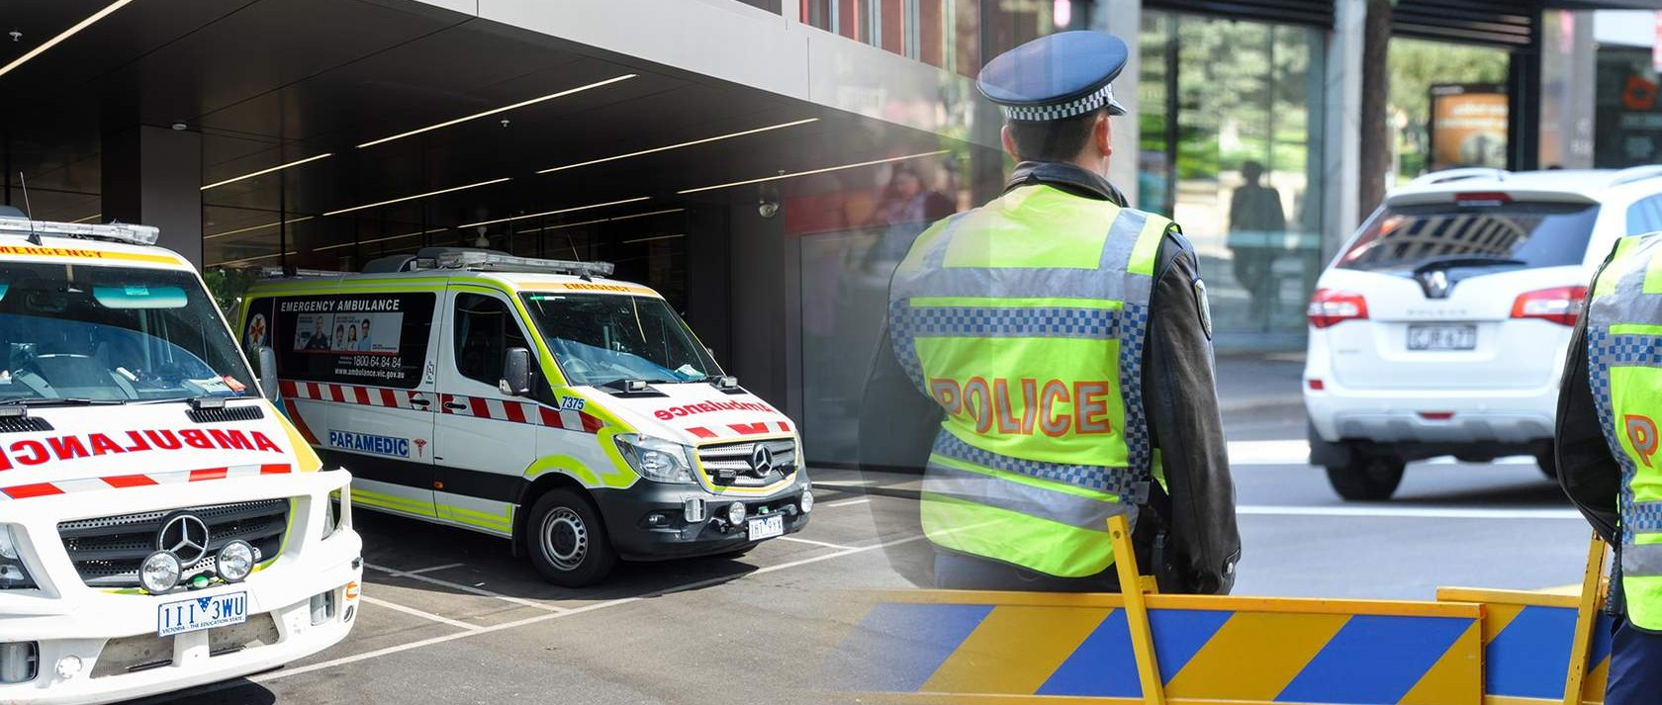

Jan Lua
Copy of Copy of QC49 Police and Ambulance
Intervention Planpdf1



A police and ambulance intervention plan (PAIP) is a plan developed by mental health clinicians that provides speciﬁc information and strategies regarding a consumer to inform and assist the Queensland Police Service (QPS) and the Queensland Ambulance Service (QAS) to mediate a mental health event involving a consumer in the community.

Pre-requisite clinical skills:

Ability to complete and document a full mental health assessment including:

Mental state examination

Risk assessment

Acknowledgments

Introduction

CHAPTER 1: PURPOSE OF THE POLICE AND AMBULANCE INTERVENTION PLAN

PAIP background

Scenario: James (Jimmy)

PAIP description

CHAPTER 2: UNDERSTANDING THE PAIP PATHWAY

Incident pathways

CHAPTER 3: WHEN TO COMPLETE A POLICE AND AMBULANCE INTERVENTION PLAN

Who needs a PAIP?

Scenario: Carrie

Scenario: George

CHAPTER 4: FILLING OUT A POLICE AND AMBULANCE INTERVENTION PLAN

How to write a good PAIP

Scenario continued: James (Jimmy)

Now it's your turn

CHAPTER 5: REVIEW REQUIREMENTS

Release and review

CHAPTER 6: SUMMARY AND EVALUATION

"It's a learned skill"

Downloads

Completion of training

Story 1 of 17

Acknowledgments

Acknowledgment of the Traditional Custodians of the Land



‘Making Tracks’ artwork produced for Queensland Health by Gilimbaa.
Queensland Health 2010: Making tracks towards closing the gap in health outcomes for Indigenous Queenslanders by 2033 Policy and Accountability Framework Brisbane 2010; Qld Government, Making Tracks Artwork and Protocols.

Queensland Health and the Learning Centre acknowledge the Traditional Custodians of the Land and Seas and pay respect to Elders past, present and future.
We would also like to acknowledge the impacts of colonisation including: the dismantling of culture and heritage, extinguishment of language, dislocation from Land and deliberate separation of families and communities, which has profoundly impacted Aboriginal and Torres Strait Islander peoples. It has had severe social, emotional and physical consequences.
We acknowledge the lived experience of those with mental illness, those impacted by suicide or substance use, and the contribution families, friends, carers and staff make to their recovery.

CONTI NUE

Course acknowledgments

This course has been developed by the Queensland Centre for Mental Health Learning (Learning Centre) on behalf of the Mental Health Alcohol and Other Drugs Branch. We would like to recognise and thank the following for their valuable contributions:

Royal Brisbane and Women's Hospital (RBWH)

RBWH Clinical Multimedia

Metro North Hospital and Health Service

West Moreton Hospital and Health Service

Mental Health, Alcohol and Other Drugs Branch.





QO______
00Queen sland Centre for
Mental Health Learning

Clinical Excellence
Queensland
Queensland

Government

· .+ -
·

Story 2 of 17

Introduction

This module will provide an introduction to the Police and Ambulance Intervention Plan (PAIP)


Verify to continue
We detected a high number of errors from your connection. To continue, please confirm that
(and spambot).
I'm not a robot
reCAPTCHA
Privacy - Terms

CONTI NUE

A police and ambulance intervention plan (PAIP) is a plan developed by mental health clinician/s that provides speciﬁc information and strategies regarding a consumer to inform and assist the Queensland Police Service (QPS) and the Queensland Ambulance Service (QAS) to mediate a mental health event involving a consumer in the community.

This eLearning module will:

explain the background and rationale for the police and ambulance intervention plan explore its context of use

provide opportunities to practise ﬁlling out the police and ambulance intervention plan.

At the end of this module you will be able to:

describe the clinical and operational utility of the police and ambulance intervention plan (PAIP) as part of mental health service provision

describe the process of coordinating an emergency response from the point of view of the Queensland Police Service (QPS) and the Queensland Ambulance Service (QAS)

correctly identify the consumers who require a PAIP

describe the requirements of completing a PAIP

explain the need to regularly review the PAIP and describe the process to do this collaboratively

describe when and how to use the PAIP and how it may apply to your service context.

Story 3 of 17

PAIP background

Why was the PAIP developed?
Watch this video to learn why the police and ambulance
intervention plan was developed
Verify to continue
We detected a high number of errors from your connection. To continue, please confirm that
(and spambot).
I'm not a robot
reCAPTCHA
Privacy - Terms

CONTI NUE

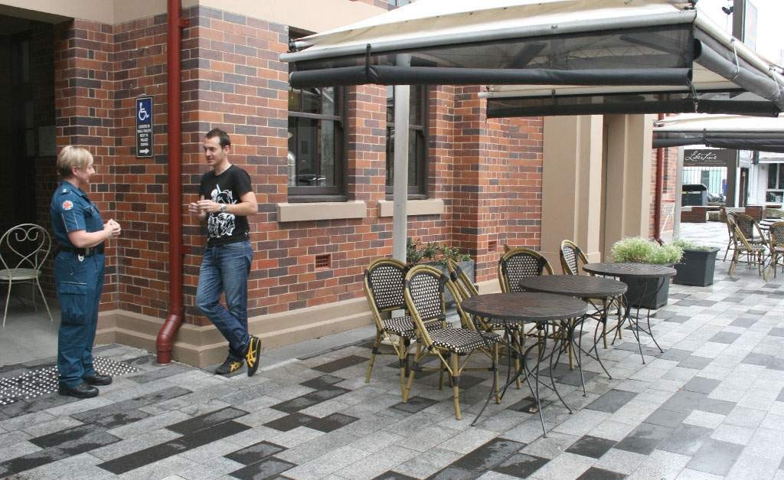

Next, we follow a scenario of James (Jimmy) who is receiving care and treatment through the local mental health service under a forensic order of the Mental Health Act 2016.

Story 4 of 17

Scenario: James (Jimmy)

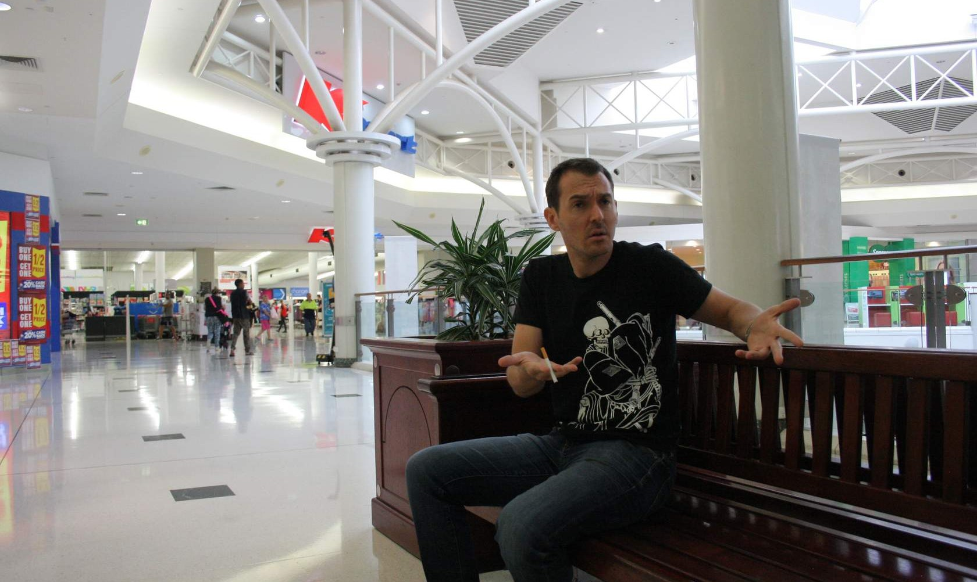
Presentation

Demographics and presenting concerns
James (Jimmy) is a 40 year old male living currently living in hostel style accommodation, receiving care and treatment through the local mental health service under a forensic order of the Mental Health Act 2016.

He has been diagnosed with paranoid schizophrenia.

Queensland Police Service (QPS) have been called after James was observed yelling at staff when he was asked to stop smoking inside the shopping centre.

The shopping centre staff describe James as being poorly groomed, and possibly intoxicated, as he appeared disoriented and agitated.

CONTI NUE


Community

Patient experience in community (i.e. shopping centre) before the arrival of QPS and current mental state
It’s 2:30 pm and James is outside a newsagency, pacing back and forth, periodically abusing the staff.

When the shopping centre security try to encourage James to leave the shopping centre, he is
observed to become more agitated, threatening to attack anyone who gets close to him and calling the security guards “Chambers’ thugs”.

This confrontation has been occurring for 20 minutes before QPS arrive.

CONTI NUE

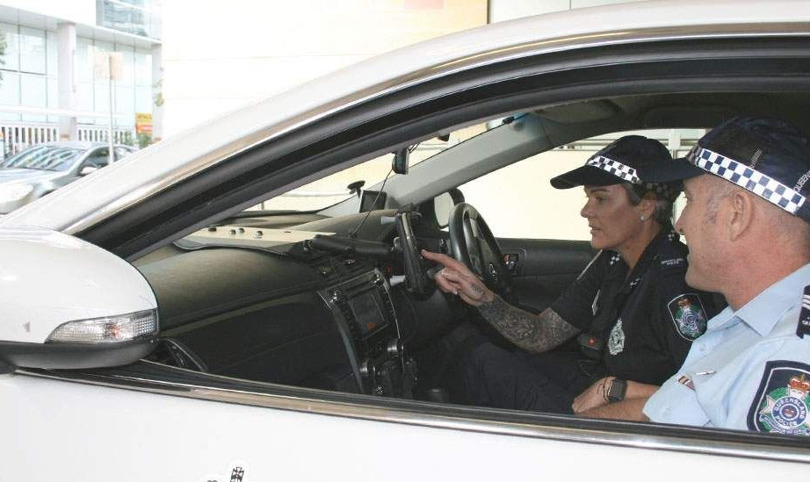
QPS ofﬁcer David

QPS ofﬁcer
David is a police ofﬁcer who has been working with QPS for ﬁve months.

David, and his partner Sally, have just ﬁnished managing a domestic violence situation; he’s tired and only has a few hours left on shift.

On the drive in, QPS provide information to David about James’ history of offending, including the carriage of weapons on his person. He also learns that James had been previously transported to hospitals by Queensland Ambulance Service (QAS) and QPS for mental health issues.

CONTI NUE

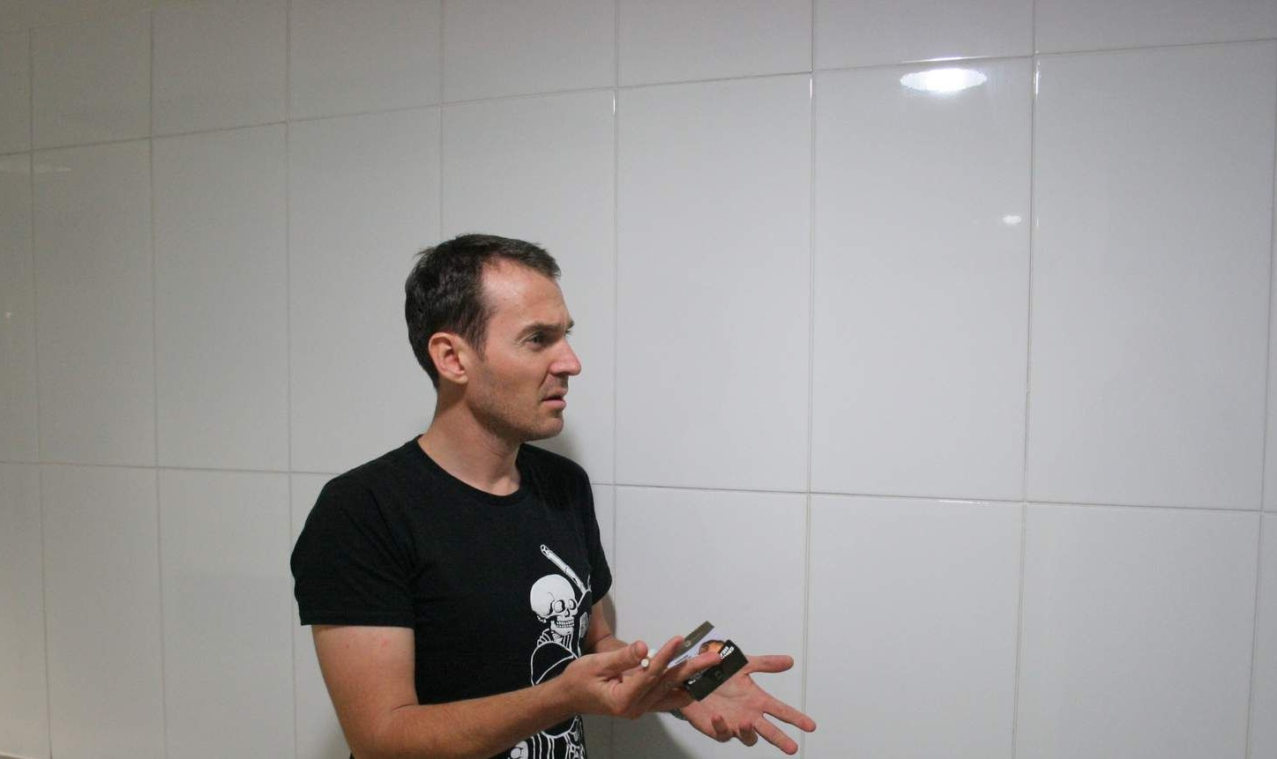
Pressures

Pressures of the role
When David arrives at the shopping centre, James appears agitated – pacing in front of the newsagents.

The shopping centre security staff inform David and Sally that James has calmed down during the last 20 minutes and that they have taken him to a quiet area of the shopping centre and told him that help is on its way.

Security inform David that there is to be an imminent inﬂux of patrons given it is late night shopping.

David’s primary concerned is the safety of the shoppers and he aims to try and move James out of the shopping centre to minimise the risk. To begin David plans to build rapport with James to ensure James does not become agitated and escalate again.

CONTI NUE

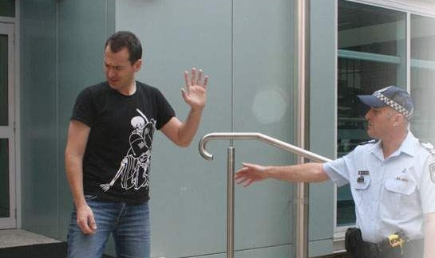
Interaction

Interaction with misinformed QPS ofﬁcer

David approaches James and begins talking to him. James appears to be intoxicated, asking David, “Are you part of Chambers’ mob?” Despite asking for clariﬁcation, David is still unclear about what James is referring to. He reassures him, saying “James, no one is after you mate”. This seems to escalate James further, leading him to accuse David of treating him like a criminal when he is actually sick.

Concerned about possibly having to restrain James, David decides to try and de-escalate James once again. He decides to ask James about his health problems.

As David begins to ask about James’ health, he seems to calm down. James explains to David that he has been having trouble breathing and has previously been in hospital for pneumonia. James is also forthcoming in talking about how his pneumonia “muddles up his thoughts” and makes him have “visions”.

At this stage, David decides that James is both physically and mentally unwell and calls an ambulance. While waiting for the ambulance to arrive, David asks James if he has any weapons on his person. James remains calm during this discussion and gives David a knife he had been carrying. James continues to be reluctant to go outside and leave this part of the shopping centre.

CONTI NUE

When QAS arrive at the scene, James appears calm and is smoking a cigarette outside the shopping centre.

David lets the QAS ofﬁcers know about James’ history of offending, as well as his health difﬁculties. David reports to QAS that he is unclear if James’ current concerns are linked to his pneumonia or poor mental health.

On talking to James, QAS discover that James has been experiencing visual hallucinations. The QAS ofﬁcers ﬁnd James hard to talk to, as he frequently becomes tangential in conversation. James often refers to someone named “Megan” but refuses to divulge information about who she is.

Although his delirium may be linked to pneumonia, the QAS ofﬁcer wonders if he is experiencing a psychotic episode. Given the limited information available, the QAS ofﬁcer informs David that James probably needs to be taken to the hospital.

CONTI NUE

Decision to transport James to hospital
Given James’ mental state and potential risk to others, David and the QAS ofﬁcer decide to transport James to the hospital.

CONTI NUE

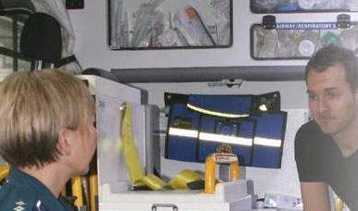
Follow up

On reviewing the incident, David feels quite frustrated that more information was not available to QPS and QAS about James’ physical and mental health.

Having heard about the interaction, James’ treating team is disappointed about how the interaction was managed and its impact on the gains James has made recently with managing his mental health.

The treating team was particularly disappointed that QAS and QPS were not aware of the symptoms associated with James’s pneumonia and its impact on his physical health and mental state.

The treating team also acknowledge that QPS could have beneﬁted from being aware of James’ history of responding poorly to any reality testing or reassurances when he is unwell.

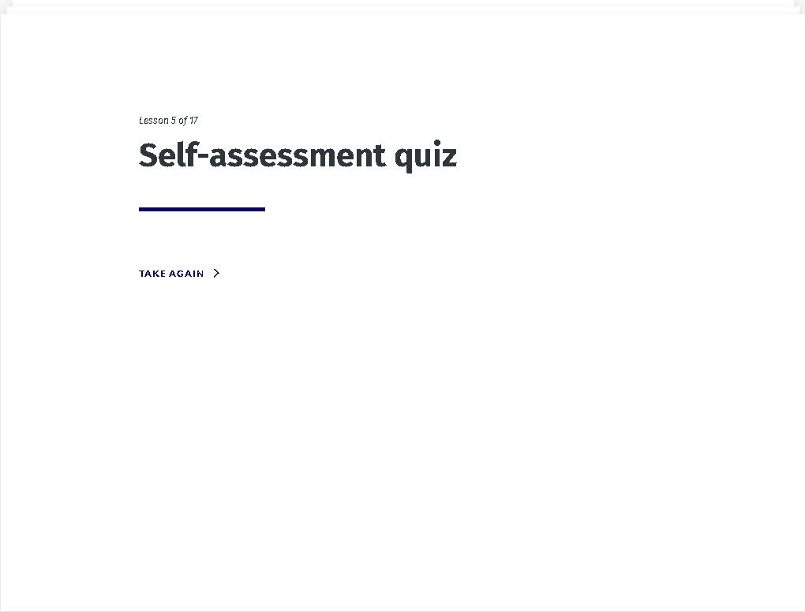

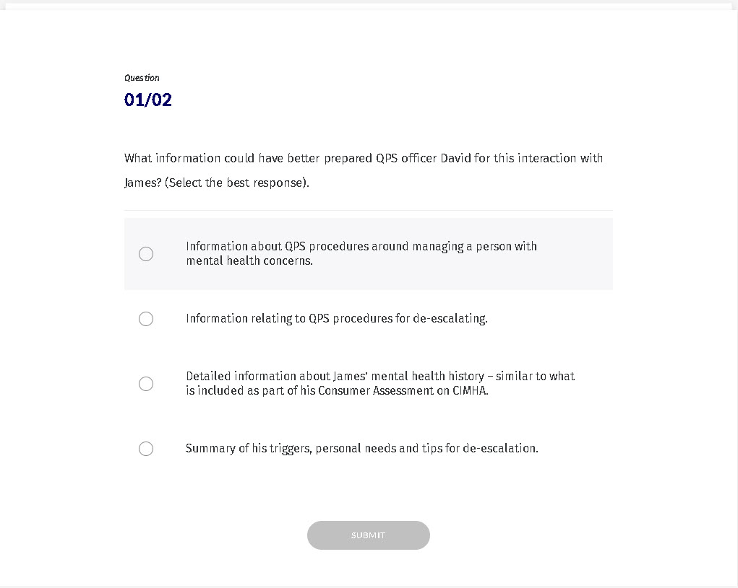

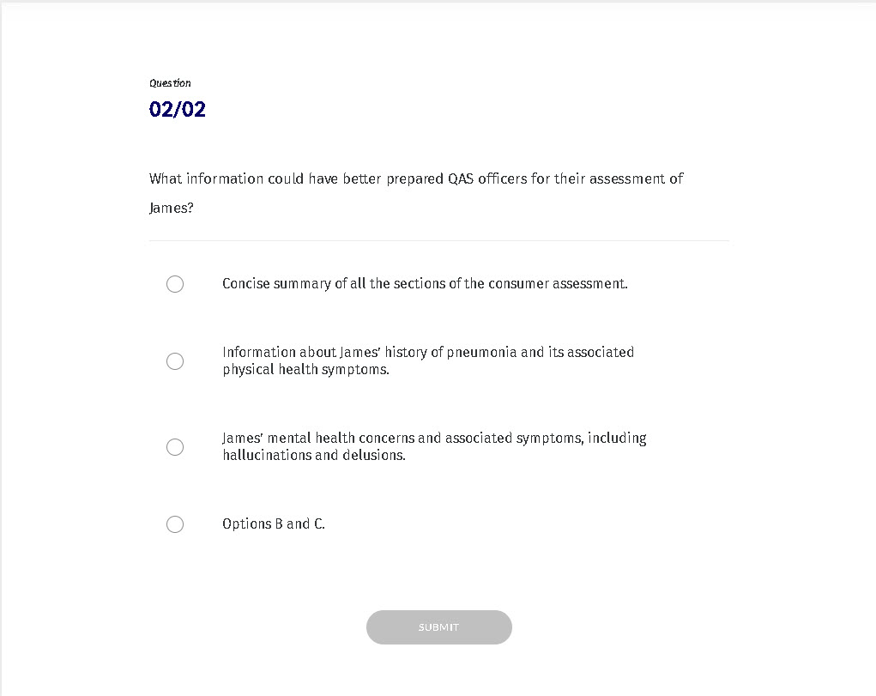

Story 6 of 17

PAIP description

What is the police and ambulance intervention plan?
In this video, Helen explains what the police and ambulance
intervention plan is:
Verify to continue
We detected a high number of errors from your connection. To continue, please confirm that
(and spambot).
I'm not a robot
reCAPTCHA
Privacy - Terms

Click here to download the police and ambulance intervention plan for reference.

CONTI NUE

What’s the difference between the acute management plan (AMP) and the police and ambulance intervention plan (PAIP)?

Acute management plan (AMP) | Police and ambulance intervention plan (PAIP)
Clinical document | Non-clinical document
Used at any entry point into the  health care system | Used at an uncontrolled event in the community
Focusses on identifying the optimal clinical pathway | Focusses on de-escalation and safe transport

Acute management plan (AMP) | Police and ambulance intervention plan (PAIP)
Identiﬁes baseline mental state  and mental state when unwell | Mental state examination is not helpful to police and paramedics
Identiﬁes clinical indicators for admission and discharge | Clinical indicators for admission and discharge are not helpful to police and paramedics

Story 7 of 17

Incident pathways

Watch this video on incident pathways

Verify to continue
We detected a high number of errors from your connection. To continue, please confirm that
(and spambot).

I'm not a robot
reCAPTCHA
Privacy - Terms

Story 8 of 17

Who needs a PAIP?

Watch this video clip that explains which consumers will beneﬁt most from a police and ambulance intervention plan.

Verify to continue
We detected a high number of errors from your connection. To continue, please confirm that
(and spambot).

I'm not a robot
reCAPTCHA
Privacy - Terms

Story 9 of 17

Scenario: Carrie


Carrie

PRES EN TA TI O N S U M M A RY

Carrie is a 63 year old woman who lives alone. She is known to mental health services and has a diagnosis of paranoid schizophrenia. Carrie has had sporadic contact with mental health services for the last 10 years and came to the attention of local police following complaints by neighbours.
Recently, Carrie herself has complained to the police about her neighbours several times – both verbally and in writing. Carrie’s mental health treating team have identiﬁed such increases in complaining behaviour to coincide with deteriorations in her psychotic illness. QPS consider her to be

a vexatious complainant.

The mental health service has identiﬁed increases in the frequency of her complaints to QPS to coincide with deteriorations in her psychotic illness, making her more paranoid. In such circumstances, Carrie is observed to become increasingly isolated, withdrawing from social supports and becoming hard to contact.

Last year, when Carrie was unable to be contacted, it was decided that police would enter her premises on the high likelihood she was still in the house. At this time, Carrie was located hiding in the house, poorly groomed and threatening to kill herself. She was hospitalised at this time, and subsequently discharged into the community with a requirement for regular contact with the treating mental health service.

CONTI NUE

Does Carrie need a police and ambulance intervention plan?
Which of the following factors are most relevant in supporting the
development of a PAIP for Carrie? Select the best two options.
Carrie has complex needs that may require a model of
care that includes a dual police and mental health response.

There has been a request for a PAIP to be developed for Carrie from another service / clinician.

Carrie may be at signiﬁcant risk in the context of an exacerbation in her mental illness.

Carrie has regular contact with Queensland Ambulance Service (QAS) and/or Queensland Police Service (QPS).

Carrie is at risk of violent behaviours towards others in the community.

Carrie has a history of substance / alcohol misuse and/or intoxication.

SUBMIT

Story 10 of 17

Scenario: George


George

PRES EN TA TI O N S U M M A RY

George is a 17 year old male diagnosed with post-traumatic stress disorder (PTSD) and personality vulnerabilities. He is currently in the care of the Department of Communities – Child Safety and lives in a residential home with two other young people. He is cared for by youth workers who report that he often becomes escalated and agitated when he doesn’t get his own way in the house. George is reported to have become physically aggressive with co-tenants and his carers, occasionally punching

holes in the walls.

More recently, George is reported to be engaging in self-harm – cutting his wrists with razors.

Incidences of aggression and self-harm have led to his carers calling QPS and QAS several times this year. However, usually by the time the QPS arrive at the house, George is calm and apologetic to the QPS ofﬁcers. With his self-harm injuries, QAS ofﬁcers have managed to treat George at home, not needing to take him to hospital.

Such incidences occur more frequently when George refuses to take his medication, and misses several appointments with his mental health service. George has not been to appointments at his mental health service for the last three months, and QAS and QPS have been called out to the home ﬁve times in two months.

CONTI NUE

Does George need a police and ambulance intervention plan?
Which of the following factors are most relevant in supporting a PAIP for
George? Select three options..
George has had frequent contact with Queensland Police
Service (QPS) and Queensland Ambulance Service (QAS).

There is a history of behaviours that pose a risk to others and self.

He has a history of substance misuse.

There appear to be current suicide risks.

There have been several requests from other services for a PAIP to be developed for George.

George may be at signiﬁcant risk in the context of an exacerbation in his mental illness.

SUBMIT

Story 11 of 17

How to write a good PAIP

In this video clip we will hear different stakeholder perspectives
on which information to include/exclude, and how to gather and present that information.
Verify to continue
We detected a high number of errors from your connection. To continue, please confirm that
(and spambot).
I'm not a robot
reCAPTCHA
Privacy - Terms

Story 12 of 17

Scenario continued: James (Jimmy)

What information should be included in a police and ambulance intervention plan for James?

The treating team have decided to develop a police and ambulance intervention plan for James because he:

has complex needs - both physical and mental health issues, including head injury

has behaviours that pose a risk to himself and others

has had recent increased contact with QAS and QPS.

CONTI NUE

On the following screens we are going to:

ﬁnd out more about James’ background

ﬁnd out what police and ambulance ofﬁcers would like to see included in James’ plan

complete a police and ambulance intervention plan for James.

CONTI NUE

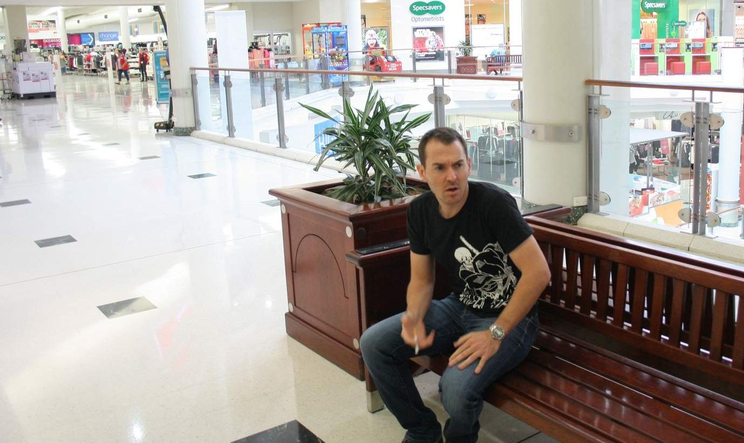
Presentation
LETS TH I N K BA C K TO JA M ES ...
James is a 40 year old male living currently living in hostel style accommodation receiving care and
treatment through the local mental health service under a Forensic Order of the Mental Health Act 2016.

He has been diagnosed with paranoid schizophrenia.

He has been brought into the emergency department (ED) by QPS, who had noticed James becoming agitated in a shopping centre.

QPS report that James began to yelling at staff when he was asked to stop smoking inside the shopping centre. QPS report that despite being intoxicated, James was cooperative with them, being upfront in letting them know about his mental health concerns.

CONTI NUE

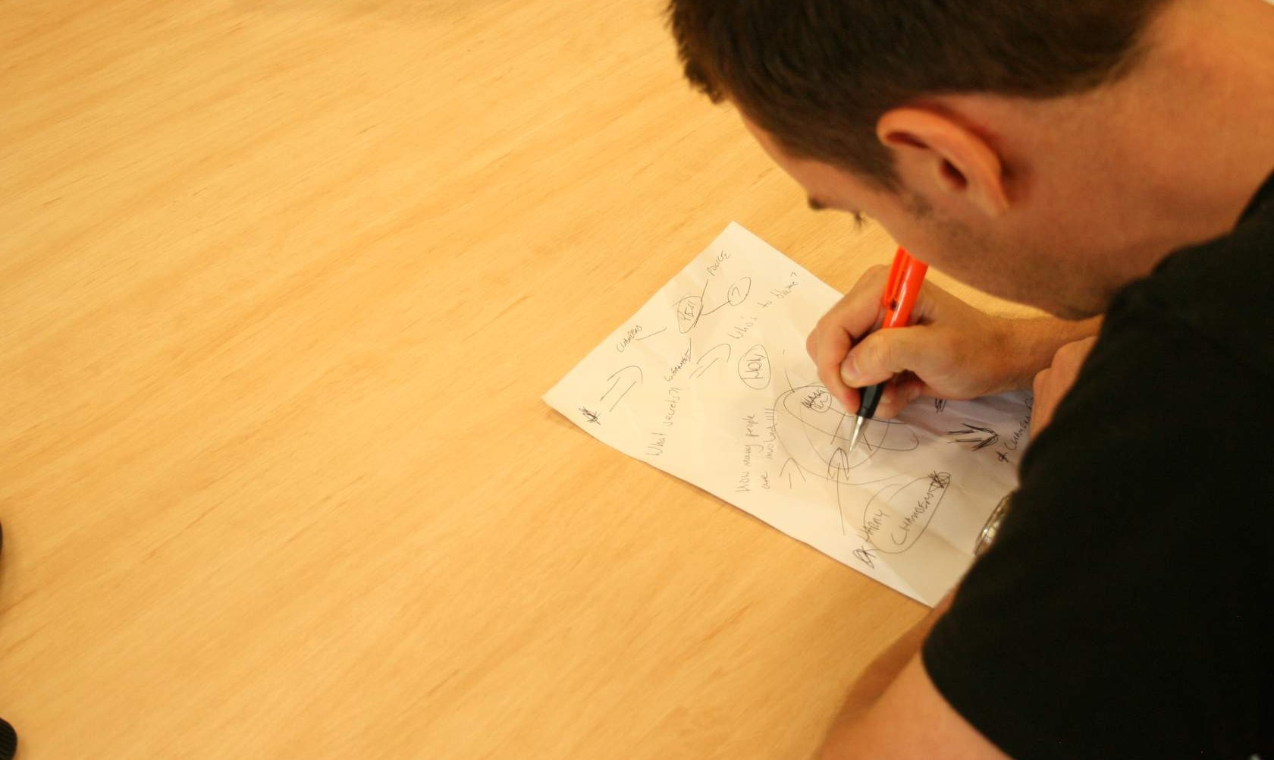
Background
BA C KGRO U N D

James, who likes to be referred to as Jimmy, was born in Echuca, Victoria and moved to Queensland as a child. His mother was a single parent and he spent a lot of time alone at home while she worked. He had episodic contact with his father who worked on cattle stations.

As a teenager, Jimmy was drawn into a local group of kids who introduced him to drugs including marijuana, hallucinogens and amphetamines. At age 16, Jimmy was involved in a physical altercation whilst intoxicated that resulted in an acquired brain injury.

Jimmy has contact twice a month via phone with his daughter who lives interstate and given his past actions when unwell he does not know her address. Jimmy’s ex-partner, his daughter’s mother, has not had any contact with Jimmy for over 15 years.

Jimmy was diagnosed with paranoid schizophrenia in his mid-twenties. He currently has a well systemized delusional system of beliefs involving his local member of parliament (Mr Harry Chambers). Jimmy displays some ambivalence about these beliefs being true, however has previously acted on these beliefs whilst unwell.

CONTI NUE


At baseline level of wellness

A T BA S ELI N E LEV EL O F WELLN ES S

Jimmy attends to his own activities of daily living, including attending to appearance. However, ﬁner details of personal grooming are often neglected – brushing teeth, strong/offensive breath.

Experiences auditory hallucination on a daily basis but this is in the background and not subjectively distressing.

Has a mild delay in processing and responding to information due to a head injury. Enjoys reggae music and likes listening to 97.3FM.

CONTI NUE

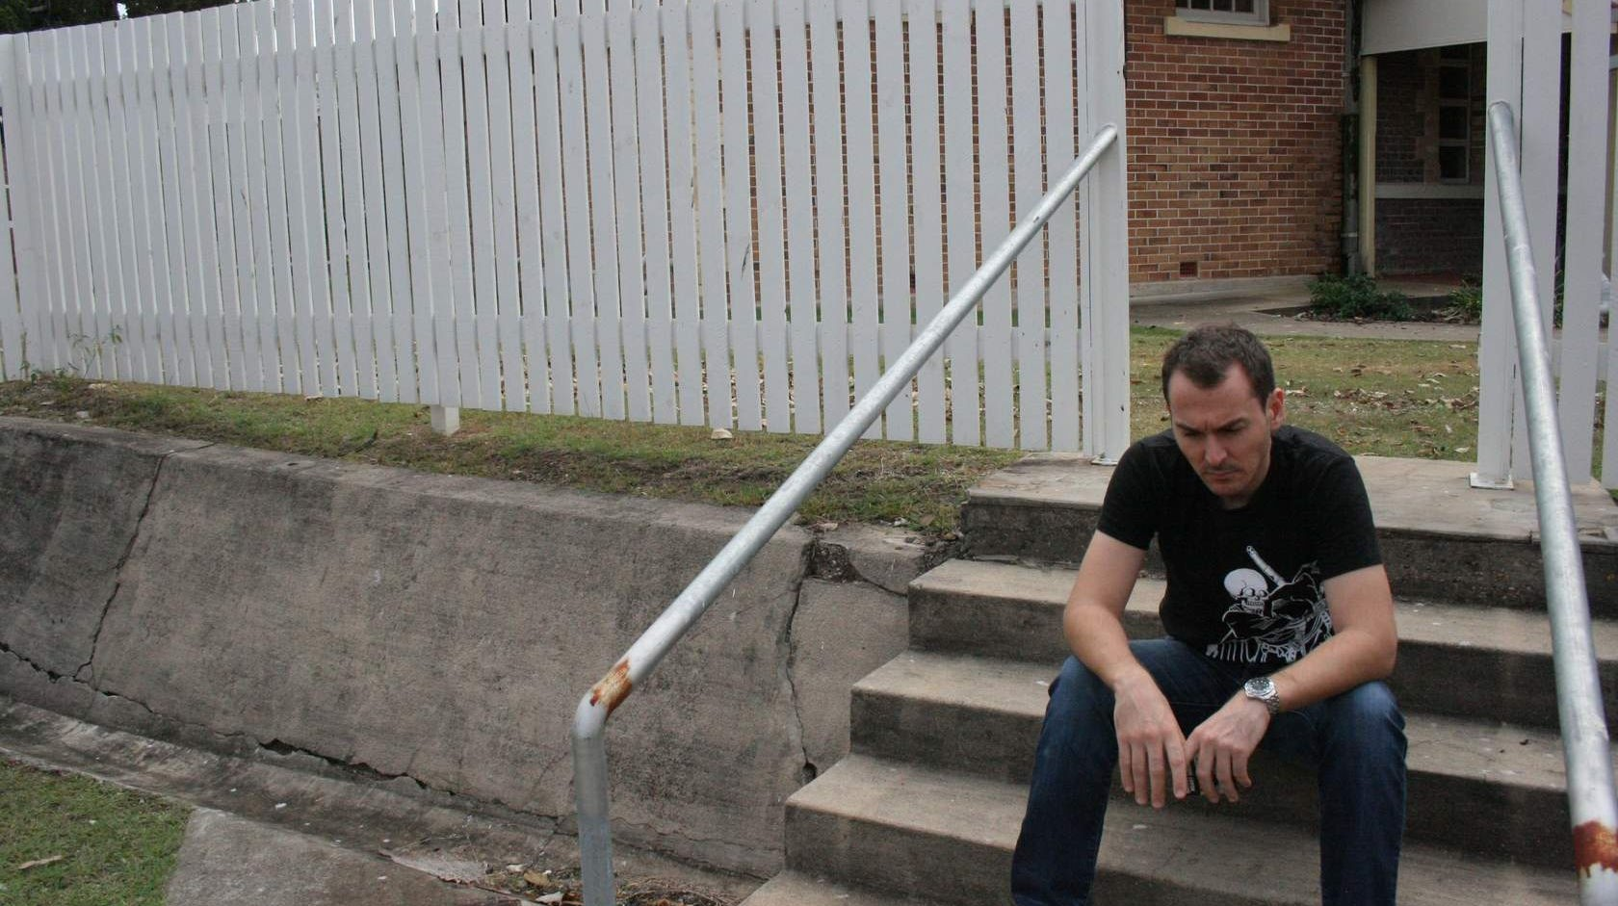
When unwell

WH EN U N WELL, J I M M Y...

Absents himself from his hostel accommodation, his mental and health care, and hides on the streets.

Becomes fearful and frightened if he believes he is being followed. In these times, he carries a weapon to protect himself, usually a knife and/or a baton.

Neglects his self-care and does not eat properly, and has been taken advantage of ﬁnancially. Has experienced command hallucinations that tell him to take drugs/alcohol because they will provide him with a “sixth sense”.

Becomes perplexed with notable disorganisation of thoughts. His cognitive capacity is complicated by the impact of his head injury.

Has responded positively to reality testing from people he has a trusting relationship with, including his daughter.

Four years ago, Jimmy was arrested at Mr Chambers’ ofﬁce, while making threats towards ofﬁce staff. This incident led to a review by the Mental Health Court and Jimmy being placed on a Forensic Order. Following the incident at his local member’s ofﬁce, a forensic assessment ascertained Jimmy, when unwell, continues to be at risk of acting on his delusions. Jimmy has never physically hurt another person though the risk remains that he may do so when unwell and genuinely believes that he needs to defend himself.

CONTI NUE




Triggers

J I M M Y 'S TRI GGERS I N C LU D E:

Stressful life events: The precipitating events for the previous admissions to hospital include his daughter becoming distressed following a breakup from her boyfriend, and an interpersonal conﬂict with a co-tenant.

Chest infection: Jimmy was admitted to a medical ward with a lower-lobe pneumonia. Given his history of being a heavy smoker and development of emphysema, Jimmy remains at risk of developing pneumonia again. On presentation, Jimmy presented as delirious and experiencing visual hallucinations which are not present when he is acutely psychotic from his mental illness. He once required one to one nursing care and additional medication to manage his level of subjective distress and agitation, due to his delirium. He responded well to intravenous antibiotics and on resolution of the delirium, returned to his baseline mental state.

Situational triggers: When unwell, Jimmy has a low tolerance to being reality tested about his delusional beliefs. During these times, Jimmy’s frustration tolerance is low, often further complicated by decreased impulse control from his head injury, nicotine withdrawal, and not being able to access a cigarette.

CONTI NUE

In this video, police and ambulance representatives explain what they would include in Jimmy’s plan.

Verify to continue
We detected a high number of errors from your connection. To continue, please confirm that
(and spambot).

I'm not a robot
reCAPTCHA
Privacy - Terms

What information do police and ambulance ofﬁcers want included in Jimmy’s PAIP?

Story 13 of 17

Now it's your turn

On the following screens we will work our way through the PAIP form for Jimmy, so that you gain conﬁdence in completing the form. You may download the form below.

pdf

CONTI NUE

We will start with the ’Person Context’ section of the form:
The Person Context section is a recovery statement that is consumer focused.
Which of the following paragraphs is the most appropriate for the person context section of the form? (Select one option).
James likes to be called Jimmy. He was born in Victoria
and it is unclear where his parents are at this time.

James is in contact with his daughter, Megan, via the telephone. They had a falling out a few years back and Megan has not disclosed to Jimmy where she currently lives. She is, however, happy to keep in touch via telephone contact.

James is an engaging and polite man when well. His appearance is marked by a distinct lack of attention to ﬁner details of his personal grooming – such as cleaning his teeth. He also had strong offensive breath.

Despite incidences where he has threatened aggression, Jimmy has not been aggressive towards others. He is willing to engage with professionals and likes to discuss his love of reggae music.

James likes to be called Jimmy. Jimmy lives in supported accommodation. He spends his days at the local drop in centre. He has a supportive relationship with John the hostel manager, a support worker and one of the police liaison ofﬁcers from the local station. He also has contact twice a month via phone with his daughter Megan.

James is a 40 year old paranoid schizophrenic. He has presented to ED 4 times last year. Some of these presentations have involved him making verbal threats. He also has a systematised delusional belief that involves the Australian Federal Police and his local member, Mr Harry Chambers conspiring against him.

SUBMIT

CONTI NUE

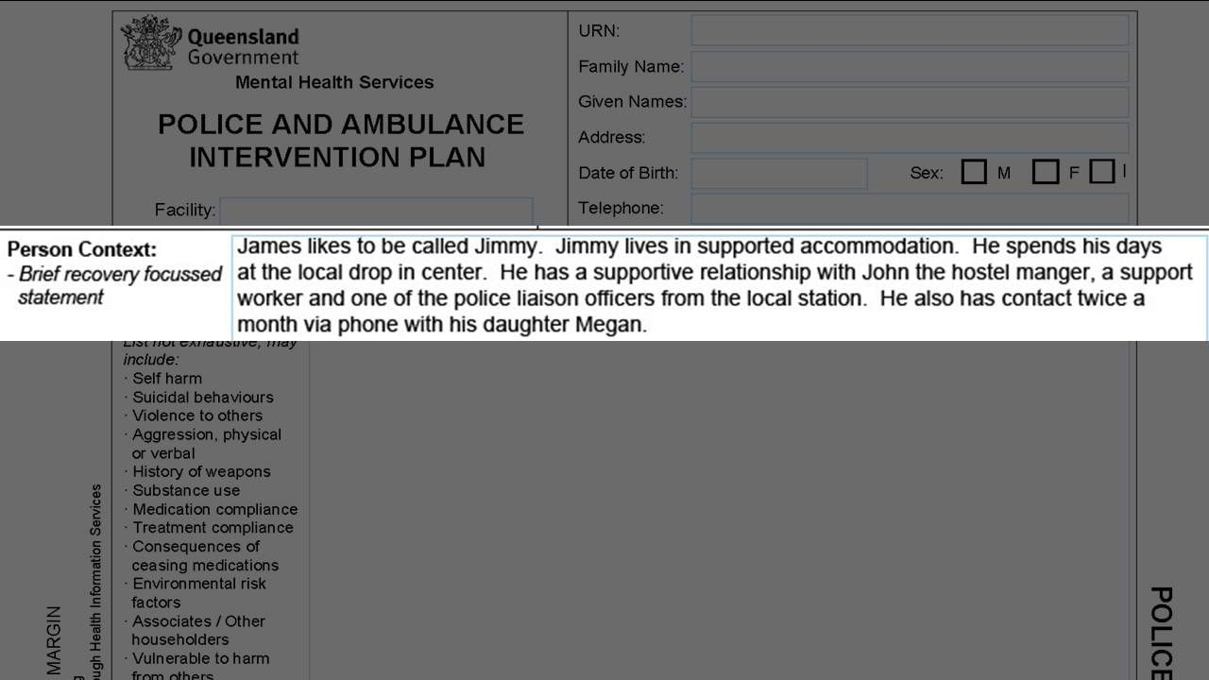

Below is an example of the ‘Person Context’ section completed for Jimmy:

CONTI NUE

The next section of the form is the ‘Identiﬁed Risks’ section.

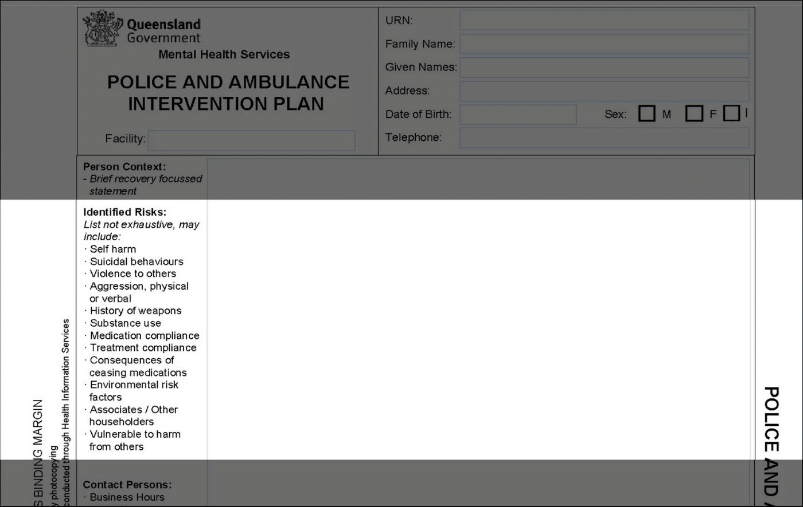

CONTI NUE

CONTI NUE

Below is an example of how the ‘Identiﬁed Risks’ section could be completed for Jimmy:

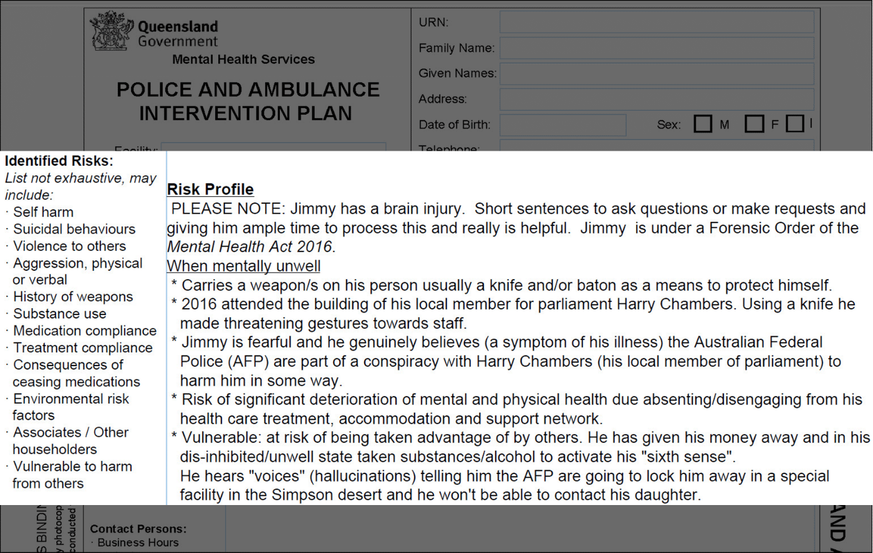

CONTI NUE

The next section of the form is the ‘What to expect when attending’ section.

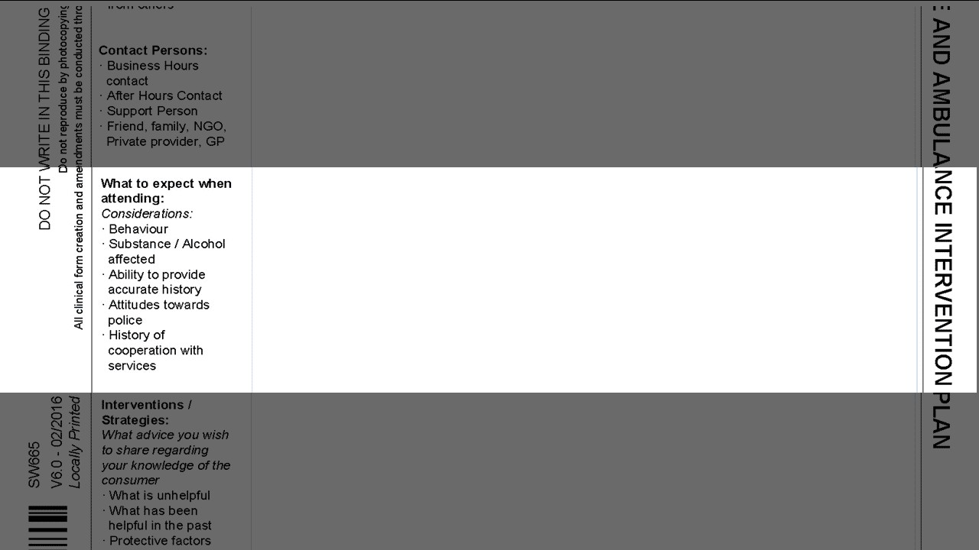

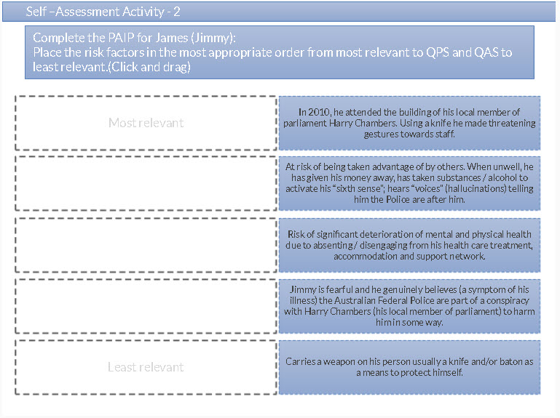

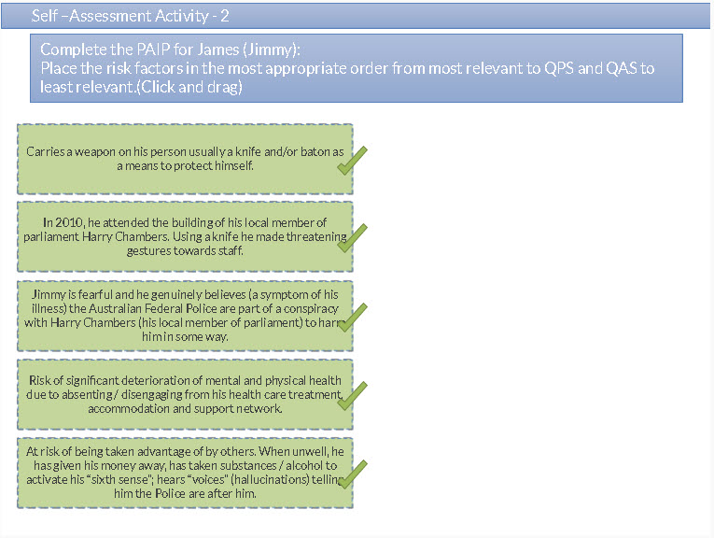CONTI NUE

Complete the PAIP for James (Jimmy): Using behaviourally speciﬁc
language.
Choose the three correct options below that are concise descriptions of
behaviours that indicate that James is becoming unwell and what to expect when attending (i.e., non-judgemental, objective descriptions, free of clinical jargon).

Signs that Jimmy is becoming unwell include:

Delivering letters to his local police station describing conspiracy theories about the AFP and his local member, Harry Chambers.

Displaying electronegative features consistent with his diagnosis of schizophrenia, including psycho-motor agitation.

Accusing random people of working with Harry Chambers, when he is well aware that these are just his delusions.

Absenting himself from his mental health treatment and/or his accommodation.

Wandering around Harry Chambers’ ofﬁce despite knowing he is banned from the area.

SUBMIT

CONTI NUE

Complete the PAIP for James (Jimmy): Using behaviourally speciﬁc language.

Choose the two correct options below that are concise descriptions of behaviours that indicate that James is becoming unwell and what to expect when attending (i.e., non-judgemental, non-objective descriptions, free of clinical jargon).

When approached by police, James:

His head injury has resulted in diminished cognitive capacity and expressive language problems.

Challenged ofﬁcers with a weapon.

Tends to not listen to professionals, often talking over people, even when he doesn’t have a point to make.

Has attempted to run away.

SUBMIT

CONTI NUE

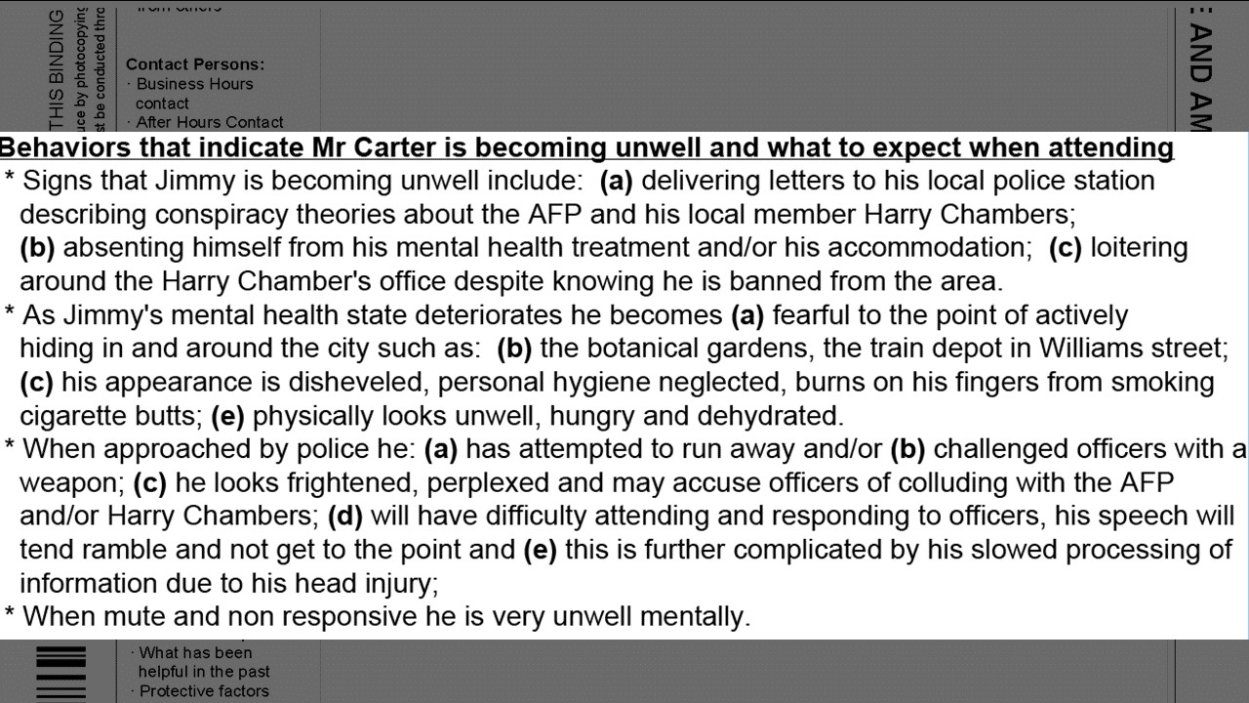

Below is an example of how the ‘What to expect when attending’ section could be completed for Jimmy:

CONTI NUE

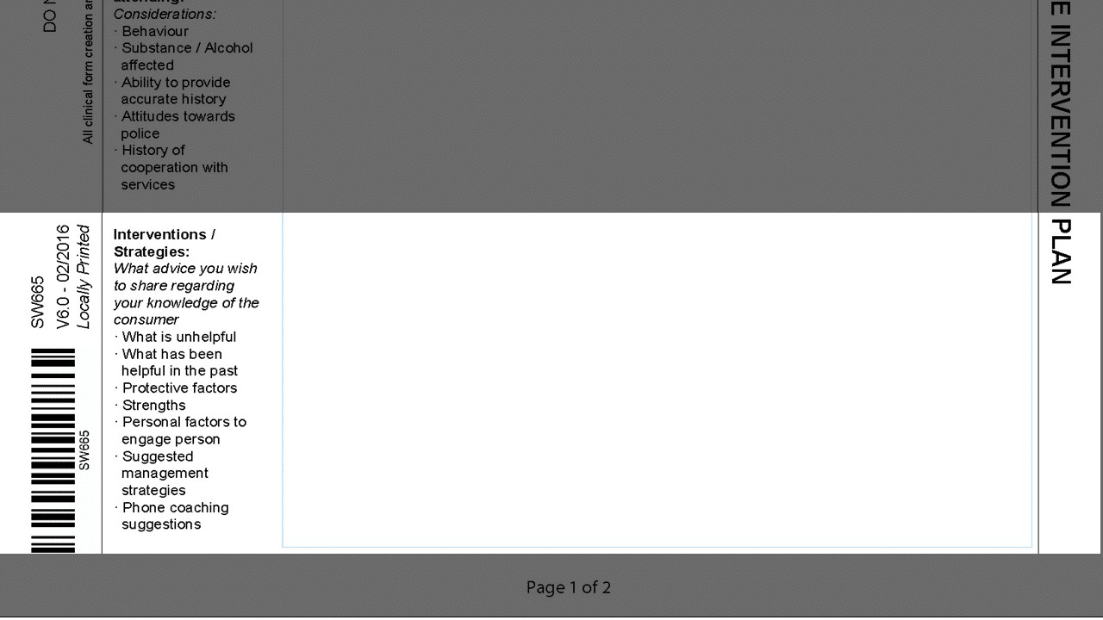

The next section of the form is the ‘Interventions / Strategies’ section.

CONTI NUE
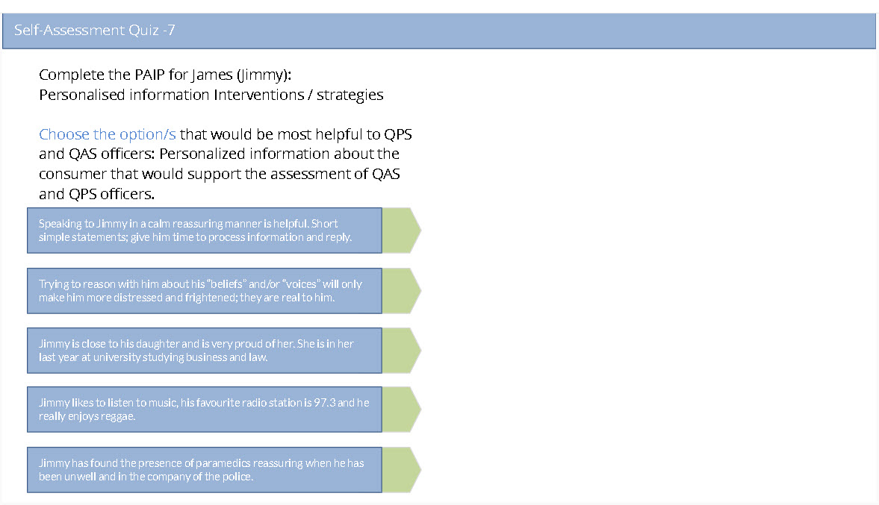

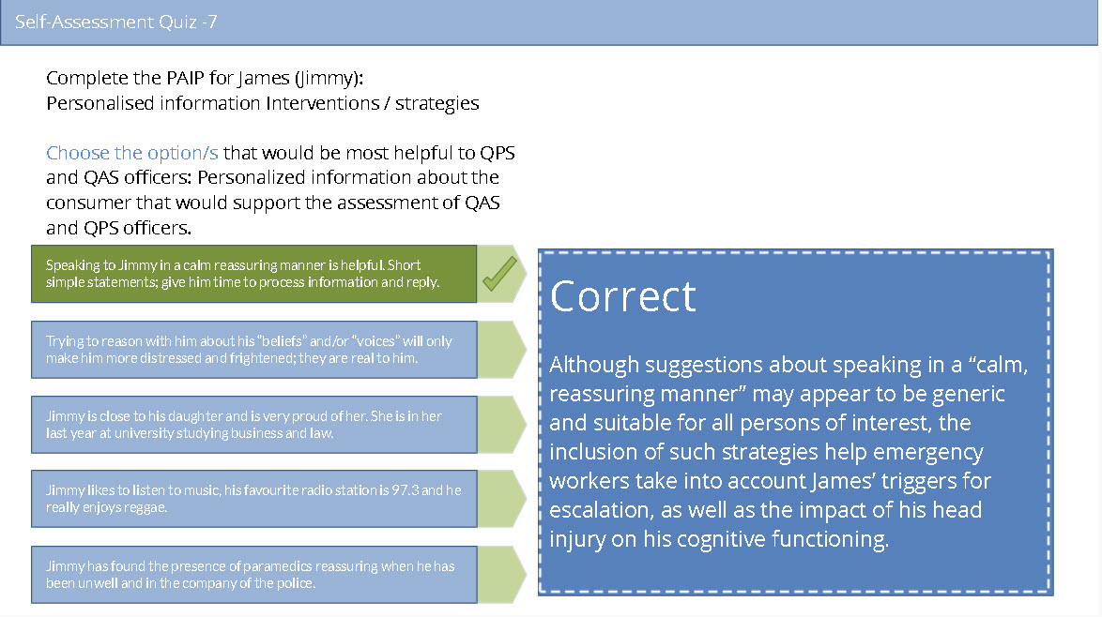

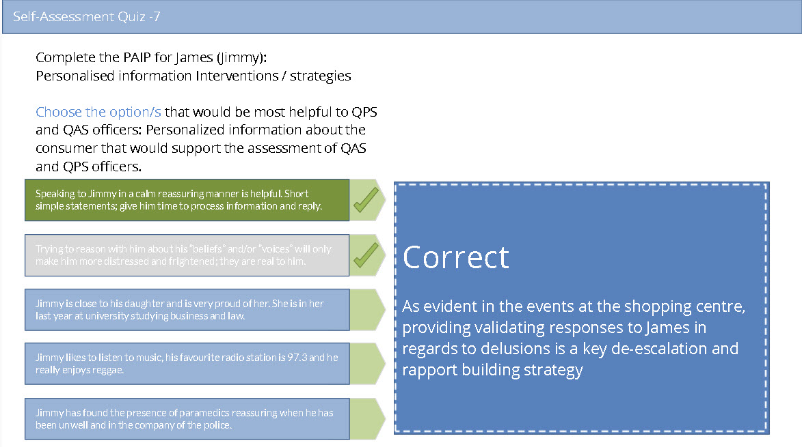
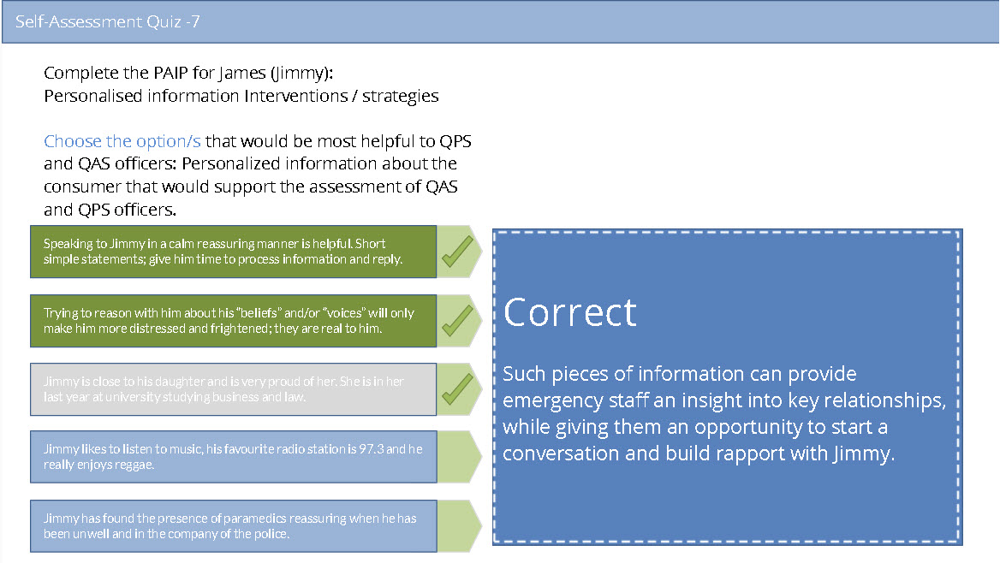
CONTI NUE
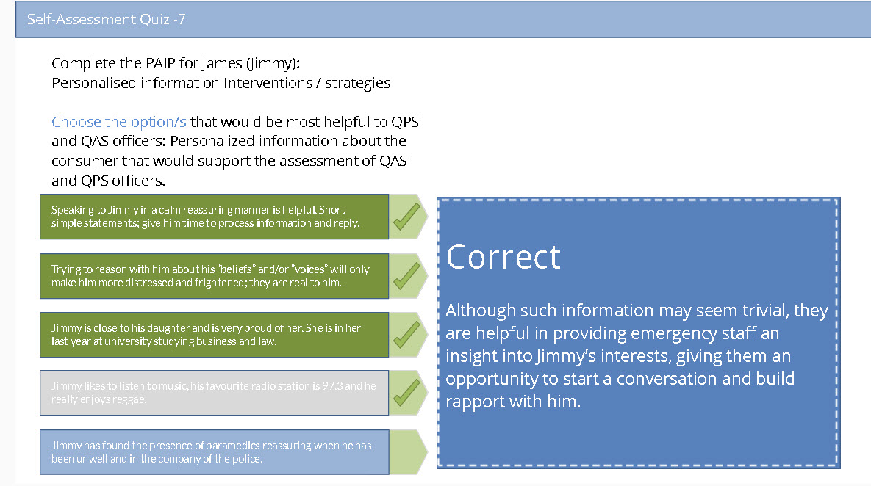

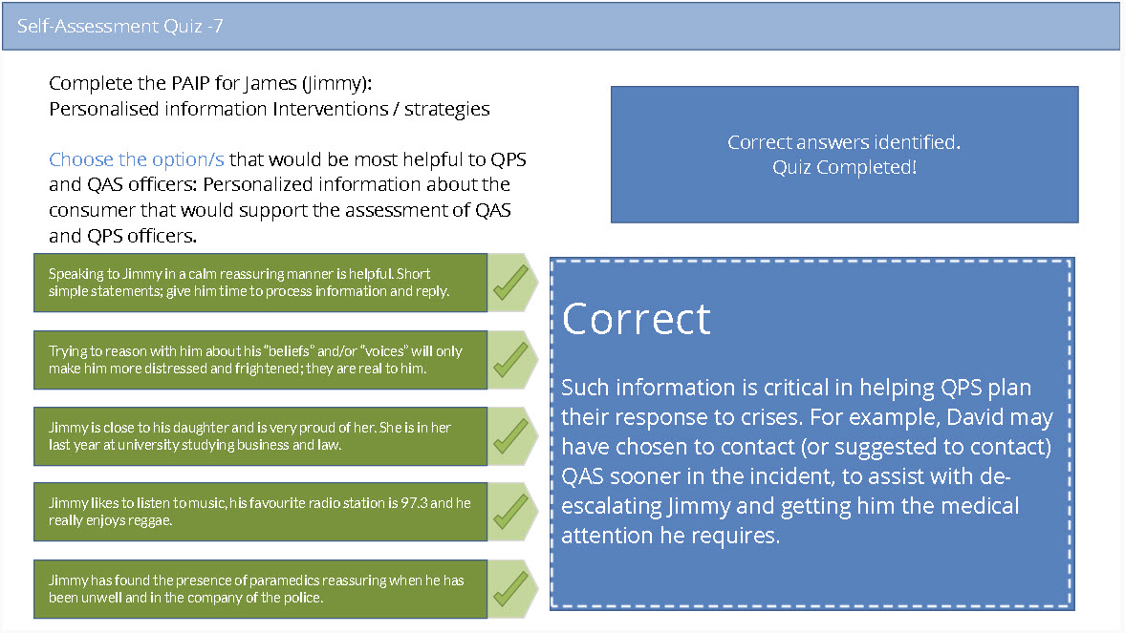

View or download Jimmy's completed PAIP form below

Download:
https://www.qcmhl.qld.edu.au/download/paip_pdf/Police_and_Ambulance_Intervention_Plan.pdf

https://www.qcmhl.qld.edu.au/download/paip_pdf/paip_James_Robert.pdf

https://www.qcmhl.qld.edu.au/download/paip_pdf/paip_Jimmy_background.pdf

tory 14 of 17

Release and review

Releasing the PAIP requires:

a multidisciplinary team review

a quality assurance review with your nominated police and ambulance liaison clinician (mental health intervention coordinator)

release to QAS and QPS via local established processes (e.g. email).

CONTI NUE

Watch this video on releasing the PAIP
Verify to continue
We detected a high number of errors from your


connection. To continue, please confirm that
(and spambot).
I'm not a robot
reCAPTCHA
Privacy - Terms

Story 15 of 17

"It's a learned skill"

CONTI NUE
Verify to continue
We detected a high number of errors from your connection. To continue, please confirm that
(and spambot).
I'm not a robot
reCAPTCHA
Privacy - Terms



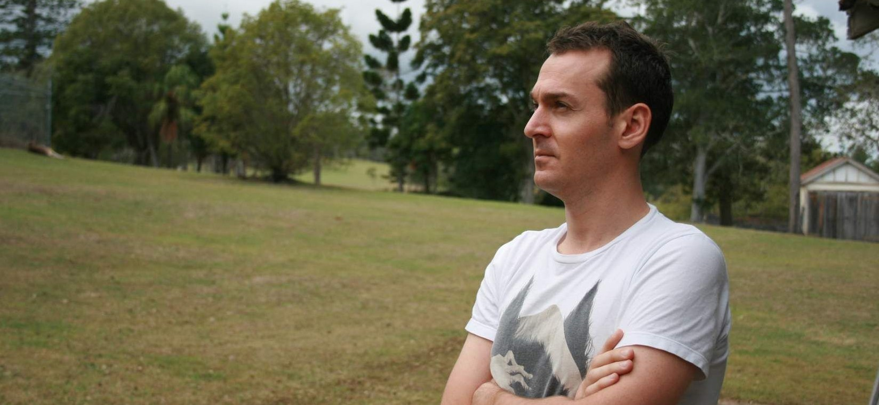
Summary

The PAIP is a non-clinical, plain English document.

Police and ambulance ofﬁcers respond to uncontrolled events in the community.

QPS are the lead agency for managing the scene. Safety is their priority.

QAS are the lead agency for providing an emergency health care response and transport.

The PAIP should include risks in hierarchical order (e.g. carriage of weapons ﬁrst), triggers, intervention strategies and tips for de-escalation.

Small details about the consumer’s everyday life can be incredibly useful to police and ambulance ofﬁcers e.g. pets, favourite football teams, grandchildren.

Ambulance ofﬁcers need enough medical information to provide an emergency medical response.

The PAIP should be no more than 2 pages, use bullet points, and behaviourally speciﬁc language.

Story 16 of 17

Downloads

Blank Police and Ambulance Intervention Plan (PDF)

OPEN PDF

Jimmy’s background information (PDF)

OPEN PDF

Jimmy’s completed plan (PDF)

OPEN PDF

Story 17 of 17

Completion of training


You have now completed the Police and Ambulance
Intervention Plan eLearning resource.
Please complete the short evaluation survey located outside
of this module, your responses will help to improve this resource.

